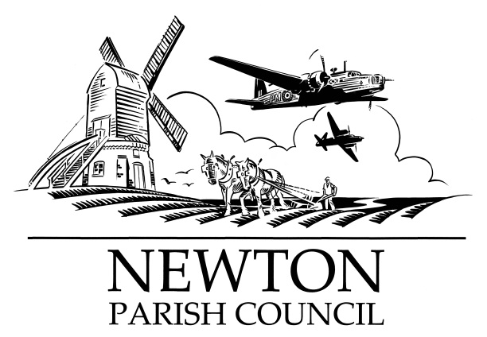
Parish Clerk: Bill Banner

Clerk’s address:

25 The Green, Radcliffe-on-Trent, Nottingham, NG12 2LA

Telephone: 0115 933 5921

Email: billbanner1@virginmedia.com
Parish website: https://www.newton-pc-notts.co.uk/

MEETING NOTICE TO THE PUBLIC

The monthly meeting of the Council is to be held in the

ATC Building, off Wellington Avenue, NEWTON on TUESDAY 06 November 2018 at 7.30pm and members of the public are invited to attend and listen to the proceeding

The Agenda for the meeting will be as follows:

- Apologies for Absence
- Declarations of Interest
- Chairman’s announcements
- Minutes of the Council Meeting held on 02 October 2018 for approval
- Clerk’s report on Matters and Actions arising from the Minutes
- Open Session for Members of the Public to Raise Matters of Council Business. Limited to 15 Minutes
- Council Social Media Communications
- Community Hall - Provision
- Wellington Avenue Play Area
- The Kestrel Play Park
- New Planning Applications
- Recent Rushcliffe Borough Council Decisions:
- Wellington Avenue & Main Street – Traffic calming measures
- Wellington Avenue – Lorries & Speeding
- Newton Pathway
- Battle Close area – land drainage
- Trees
- Fence
- Finance
- Register of Members interests
- Councillors’ Reports
- Correspondence
- Reports from Outside Organisations
- Date of Next Meeting: Tuesday 04 December 2018

Bill Banner

Clerk to the Council 26 October 2018

