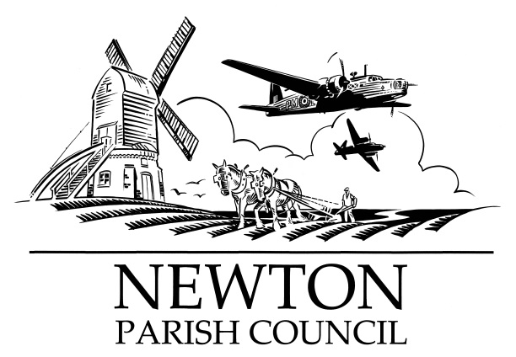
Parish Clerk: Bill Banner
Clerk’s address:
25 The Green, Radcliffe-on-Trent, Nottingham, NG12 2LA
Telephone: 0115 933 5921
Email: billbanner1@virginmedia.com
Also: clerk@newton-pc-notts.co.uk
Parish website: https://newton-pc notts.co.uk

Notts Police to carry out a firearms training exercise

Please note that on the 20th of November, there will be gun shots & other pyrotechnics for a short period of time at the Newton Nottingham LLP undeveloped area

We have been assured that there is no cause for alarm

Bill Banner
Clerk 29 October 2018

