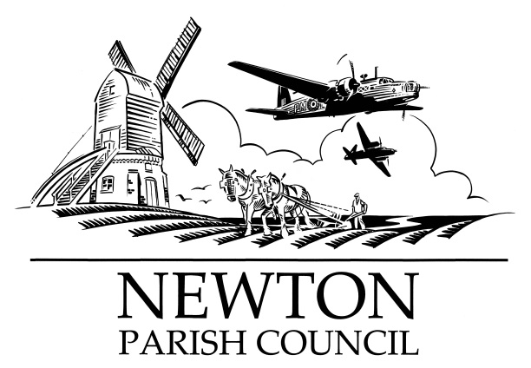

Parish Clerk: Bill Banner

Clerk’s address:

25 The Green, Radcliffe-on-Trent, Nottingham, NG12 2LA

Telephone: 0115 933 5921

Email: [**billbanner1@virginmedia.com**](mailto:billbanner1@virginmedia.com)

Parish website: [**https://www.newton-pc-notts.co.uk/**](https://www.newton-pc-notts.co.uk/)

**MEETING NOTICE TO THE PUBLIC**

**The monthly meeting of the Council is to be held in the**

**ATC Building, off Wellington Avenue, NEWTON on TUESDAY 05 February 2019 at 7.30pm and members of the public are invited to attend and listen to the proceeding**

**The Agenda for the meeting will be as follows:**

1. Apologies for Absence
2. Declarations of Interest
3. Chairman’s announcements
4. Minutes of the Council Meeting held on 04 December 2018 for approval
5. Clerk’s report on Matters and Actions arising from the Minutes
6. Open Session for Members of the Public to Raise Matters of Council Business. Limited to 15 Minutes
7. Community Hall - Provision
8. Wellington Avenue Play Area - Glass Bank provision
9. The Kestrel Play Park
10. Meadfleet Liaison Group
11. MOD Land – No access – not Public RoW
12. Planning Applications: 18/01468/REM - Land west of Chapel Lane, Bingham
13. Recent Rushcliffe Borough Council Decisions:18/01830/FUL – 10 Main Street – Grant Permission
14. Wellington Avenue & Main Street – Traffic calming measures
15. Wellington Avenue – Lorries & Speeding
16. Newton Pathway
17. Battle Close area – land drainage
18. Fence
19. Finance
20. Register of Members interests
21. Councillors’ Reports
22. Correspondence
23. Reports from Outside Organisations
24. Date of Next Meeting: **Tuesday 05 March 2019**

*Bill Banner*

*Clerk to the Council 29 January 2019*