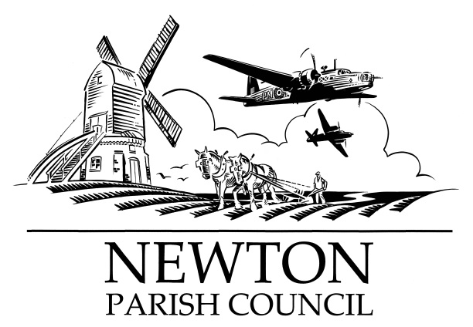

Parish Clerk: Bill Banner

Clerk’s address:

25 The Green, Radcliffe-on-Trent, Nottingham, NG12 2LA

Telephone: 0115 933 5921

Email: [**billbanner1@virginmedia.com**](mailto:billbanner1@virginmedia.com)

Parish website: [**https://www.newton-pc-notts.co.uk/**](https://www.newton-pc-notts.co.uk/)

**MEETING NOTICE TO THE PUBLIC**

**The monthly meeting of the Council is to be held in the**

**ATC Building, off Wellington Avenue, NEWTON on TUESDAY 02 April 2019 at 7.30pm and members of the public are invited to attend and listen to the proceeding**

**The Agenda for the meeting will be as follows:**

1. Apologies for Absence
2. Declarations of Interest
3. Chairman’s announcements
4. Minutes of the Council Meeting held on 05 March 2019 for approval
5. Clerk’s report on Matters and Actions arising from the Minutes
6. Open Session for Members of the Public to Raise Matters of Council Business. Limited to 15 Minutes
7. Community Hall – Provision update
8. Wellington Avenue Play Area
9. The Kestrel Play Park
10. Planning Applications:
11. Recent Rushcliffe Borough Council Decisions:
12. Wellington Avenue & Main Street – Traffic calming measures
13. Wellington Avenue – Lorries & Speeding
14. Newton Pathway
15. Battle Close area – land drainage
16. Fence
17. Finance
18. Annual Parishioners Meeting: 09 April 2019
19. Councillors’ Reports
20. Correspondence
21. Reports from Outside Organisations: Meadfleet Liaison Group
22. Date of Next Meeting: **Tuesday 07 May 2019** (incl. Annual Council Meeting)

*Bill Banner*

*Clerk to the Council 27 March 2019*