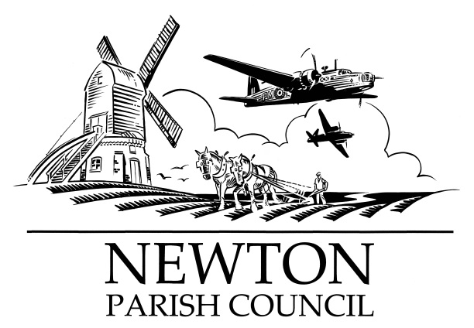
Parish Clerk: Bill Banner

Clerk’s address:

25 The Green, Radcliffe-on-Trent, Nottingham, NG12 2LA

Telephone: 0115 933 5921

Email: billbanner1@virginmedia.com
Parish website: https://www.newton-pc-notts.co.uk/

MEETING NOTICE TO THE PUBLIC

The monthly meeting of the Council is to be held in the

ATC Building, off Wellington Avenue, NEWTON on TUESDAY 12 November 2019 at 7.30pm and members of the public are invited to attend and listen to the proceeding

The Agenda for the meeting will be as follows:

AGENDA

- Apologies for Absence
- Declarations of Interest
- Chairman’s announcements
- Minutes of the Council Meeting held on 01 October 2019 for approval
- Open Session for Members of the Public to Raise Matters of Council Business. Limited to 15 Minutes
- Redrow Homes - progress
- Wellington Avenue Play Area
- The Kestrel Play Area
- Planning Applications: None
- Recent Rushcliffe Borough Council Decisions: None
- Wellington Avenue & Main Street – Interactive Speed Signs
- HGVs out of business hours
- Tree Planting
- Battle Close – land drainage update
- Pathway
- Finance: Payments to be authorised
17. Councillors’ Reports:
18. Correspondence:
19. Reports from Outside Organisations:
20. Date of Next Meeting: Tuesday 17 December 2019

Bill Banner

Clerk to the Council 05 November 2019

