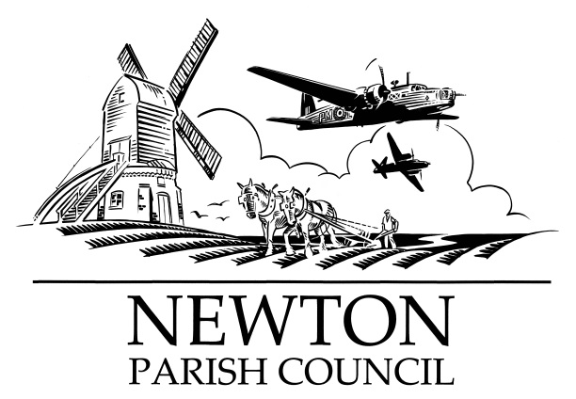
Parish Clerk: Bill Banner

Clerk’s address:

25 The Green, Radcliffe-on-Trent, Nottingham, NG12 2LA

Telephone: 0115 933 5921

Email: billbanner1@virginmedia.com
Parish website: https://www.newton-pc-notts.co.uk/

MEETING NOTICE TO THE PUBLIC

The monthly meeting of the Council is to be held by

Internet Conferencing (Zoom) on

TUESDAY 14 April 2020 at 7.30pm

Members of the public are invited to attend and to do so will need to advise the clerk of their e-mail address so the invitation to join the meeting can be sent to them on the day

The Agenda for the meeting will be as follows:

AGENDA

- Apologies for Absence
- Declarations of Interest
- Chairman’s announcements
- Minutes of the Council Meeting held on 10 March 2020 for approval
- Open Session for Members of the Public to Raise Matters of Council Business. Limited to 15 Minutes
Please submit any questions to the clerk in advance of the meeting
- Redrow Homes - progress
- RAF Newton Memorial
- Covid-19
- Wellington Avenue
- Dog Fouling
- The Kestrel Play Area
- Planning Applications: 19-02914-FUL – Bingham Leisure Centre
- Recent Rushcliffe Borough Council Decisions: 20-00215-FUL – R Packwood – Grant Permission
- Battle Close – land drainage update
- Finance: Payments to be authorised
- Councillors’ Reports:
16. Correspondence:
17. Reports from Outside Organisations:
18. Date of Next Meeting: Tuesday 12 May 2020 (Note: This is also the Annual Council Meeting)

Bill Banner

Clerk to the Council 07 April 2020

