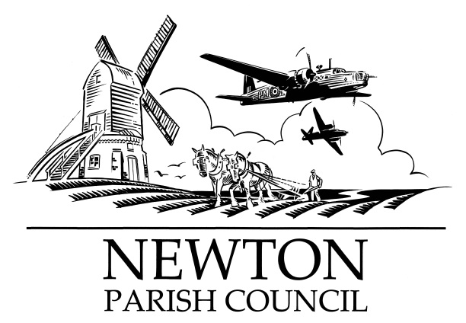
Parish Clerk: Bill Banner

Clerk’s address:

25 The Green, Radcliffe-on-Trent, Nottingham, NG12 2LA

Telephone: 0115 933 5921

Email: billbanner1@virginmedia.com
Parish website: https://www.newton-pc-notts.co.uk/

MEETING NOTICE TO THE PUBLIC

The monthly meeting of the Council is to be held in the

ATC Building, off Wellington Avenue, NEWTON on TUESDAY 02 July 2019 at 7.30pm and members of the public are invited to attend and listen to the proceeding

The Agenda for the meeting will be as follows:

AGENDA

- Apologies for Absence
- Declarations of Interest
- Chairman’s announcements
- Redrow Homes: Alex Kenny
- Minutes of the Council Meeting held on 07 May 2019 for approval
- Open Session for Members of the Public to Raise Matters of Council Business. Limited to 15 Minutes
- Community Hall – Provision update
- Wellington Avenue Play Area
- The Kestrel Play Area – Emergency Access
- Planning Applications:
- Recent Rushcliffe Borough Council Decisions:
- Wellington Avenue & Main Street – Interactive Speed Signs
- Commercial Road – night usage
- Battle Close – land drainage update
- Fence – removal update
- Streetfest
17. Finance:
a) Payments to be authorised
b) Q1 Budget review
18. Councillors’ Reports:
19. Correspondence:
20.. Reports from Outside Organisations:
21. Date of Next Meeting: Tuesday 03 September 2019

Bill Banner

Clerk to the Council 27 June 2019

